--=================================================================================
--===============================CIS 310 ASSIGNMENT 2===============================
--=================================================================================
/*
STUDENT NAME:
STUDENT ID:
SUBMISSION DATE:
*/
1. For the database shown below, answer the following 3 questions: (10 pts)
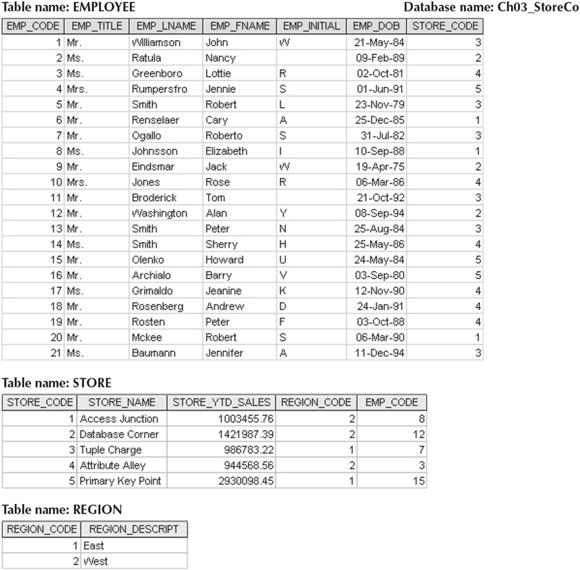
- For each table, identify the primary key and the foreign key(s) by filling in below table. If a table does not have a foreign key, write None.
TABLE | Primary Key | Foreign Key(s)
EMPLOYEE
STORE
REGION
- Do the tables exhibit entity integrity? Answer yes or no, and then explain your answer by filling out below table.
TABLE | Entity Integrity | Explanation
EMPLOYEE
STORE
REGION
- Do the tables exhibit referential integrity? Answer yes or no, and then explain your answer by filling out below table. Write NA (Not Applicable) if the table does not have a foreign key.
TABLE | Referential Integrity | Explanation
EMPLOYEE
STORE
REGION

- 2. Write the business rules for the relationships you identify in Figure from Question 1. (10 pts)
- --*Hint, there can be more than 1 relationship between 2 entities. Take a closer look at Employee and Store.

- 3: Create a full ERD using MS Visio for the database in Question 1. All required elements as covered in class must be included for full credit. Other tools such as hand drawn will receive partial credit. (10 pts)

